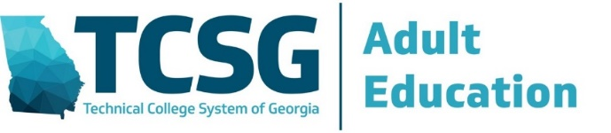

STANDARDS-BASED EDUCATION WORKSHOP SERIES
PART 1 – CLASSROOM RESOURCE ALIGNMENT WORKSHOP
POST-WORKSHOP ACTIVITY – SWOT ANALYSIS

Date: | Program Name:
Name: | Email Address:

Thank you for attending the first workshop in the three-part Standards-Based Education Workshop Series. While there was much covered in the workshop, we would like your comments and feedback on several areas related to your ability and your program’s ability to move forward with the planning and preparation required to implement a standards-based instructional focus across all classrooms found within your program. This activity is a Strengths, Weaknesses, Opportunities, and Threats Analysis, or better known as a SWOT Analysis.

If you elect, you may share your comments with others in your program; otherwise when you submit this completed form following the directions provided below, your feedback will be aggregated into a data collection initiative and combined with all others participating in these workshop offerings provide a statewide assessment with its results. Feedback received will be compiled with other submissions to gauge what was learned and to guide future professional development offerings. Thank you in advance for your time, your feedback, and your contributions.

Activity Directions and Submission Checklist

- Answer the questions from:
- your individual perspective as an adult educator or program staff member, and
- from your view of your organization.

- Email this completed form to ksharpton@tcsg.edu and kmcdaniel@tcsg.edu within 30 days after attending the workshop.

- Please include the following as part of the email’s subject line (SWOT Activity – Your Program Name – Your Name).

STRENGTHS
S1 – What knowledge and skills do you/your organization have that WILL HELP with evaluating classroom resources?
Individual Perspective | Organizational Perspective
S2 – What knowledge and skills do you/your organization have that WILL HELP with integrating standards into classroom instructional practices?
Individual Perspective | Organizational Perspective

WEAKNESSES
W1 – Where do you think you/your organization WILL STRUGGLE when evaluating classroom resources?
Individual Perspective | Organizational Perspective
W2 – What knowledge and skills are you/your organization LACKING in terms of integrating standards into classroom
instructional practices?
Individual Perspective | Organizational Perspective

OPPORTUNITIES
O1 – What FAVORABLE OUTCOMES will result from you/your organization evaluating classroom resources?
Individual Perspective | Organizational Perspective
O2 – What FAVORABLE OUTCOMES will result from you/your organization integrating standards into classroom
instructional practices?
Individual Perspective | Organizational Perspective

THREATS
T1 – What WOULD HINDER you/your organization from evaluating classroom resources?
Individual Perspective | Organizational Perspective
T2 – What WOULD HINDER you/your organization from integrating standards into classroom instructional practices?
Individual Perspective | Organizational Perspective

