- Go to https://adultedgo.blackboard.com/and click on the “Forgot Password” option.

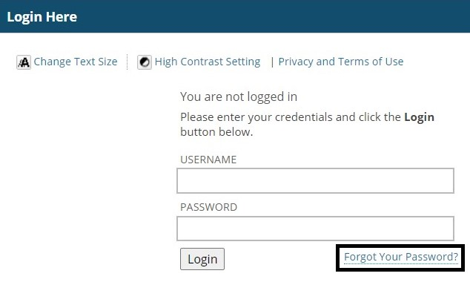

2. Enter your information for either the “Username Option” or “E-mail Address Option.” Then click submit. If you need your username, please contact your Instructor.

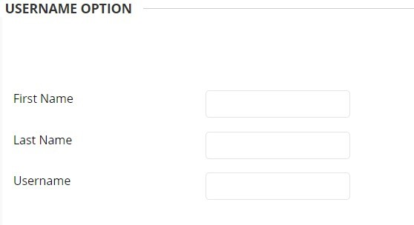 | 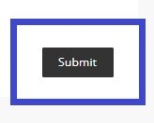  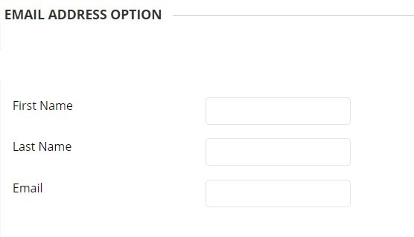
3. Once you get to this screen, go to your e-mail to reset the password. If you do not receive an e-mail or can’t access yours, please contact your Instructor.

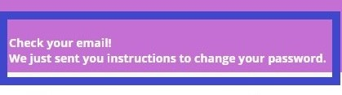

4. Open the e-mail from “Blackboard Administrator, Lost Password Notification.” Click on the blue link at the bottom to reset the password.

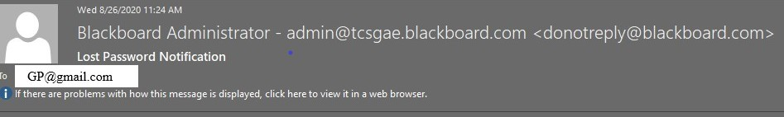

Forgot Password? This message is a response to the Forgotten Password utility on your blackboard system. If you did not use this tool to generate this message, you should contact your System Administrator immediately: admin@tcsgae.blackboard.com. To set a new password for your account, click on the URL below or past into your browser exactly as it appears. https://adultedgo.blackboard.com/webapps/blackboard/password?action=change&user=8751&passoce80FC859C
When you go to this this location, you can set your new password.

5. Enter your new password and Click “Submit.”
.

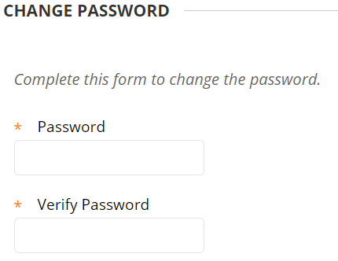

6. Now you’re all set. Go to https://adultedgo.blackboard.com/ and login.
.

